Editable Adjustable Preview PlugIn

**Rob Anderson (MacabreRob)**

# Background

Since the dawn the creation of Vixen, there has been really only one option to preview how light sequences will display, short of actually putting the whole thing together, and that has been the Adjustable Preview PlugIn, written by K.C. Oakes. This simple program, while elegant in its function, nonetheless lacked finesse when you were setting up how the various channels were to appear. This version of the PlugIn endeavors to correct that.

# Starting Out

Clicking “Plugin Setup” for the first time, you will be presented with a very familiar screen.

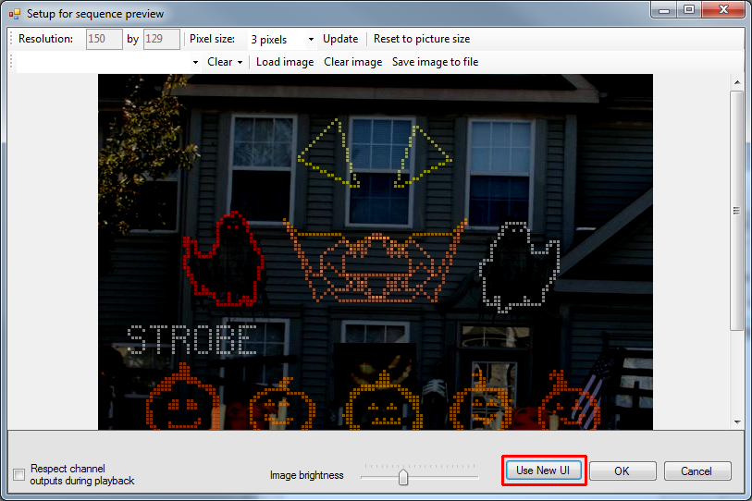

The original interface

This is the original setup window for the Adjustable Preview PlugIn, with one key difference. On the bottom right corner is a new button: “Use New UI”. Clicking this button will cause this window to close and the new, enhanced editor to open. The new window will open initially thereafter, unless you specifically tell it not to (ex. you really like the old user interface).

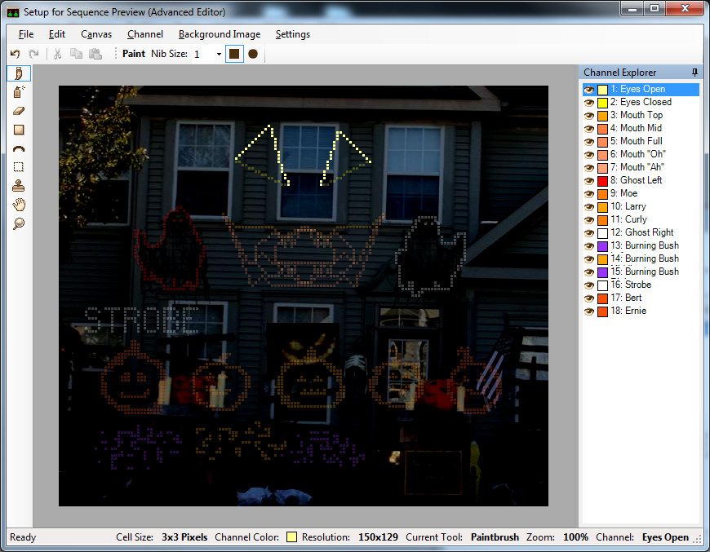  
The new, advanced interface

Immediately, you should be able to tell this ain’t your father’s Adjustable Preview editor.

# Channel Explorer

The panel on the right side of the screen is what is called the “Channel Explorer”.

# The Toolbox

All the various editing tools available